# Data delay of besmetrics application

# SOP

1. Check if there's an increase of error logs  for r1besmetrics pool from [EX2](https://srestar.vip.ebay.com/d/HoRHO7SMk/ex-2?orgId=1&theme=light&refresh=5m&var-pool=r1besmetrics&var-colo=slc&var-colo=rno&var-colo=lvs&var-resolution=sherlockio.appevent_1min&var-eventlimit=50&var-errTypes=Error&var-errTypes=Exception&var-errTypes=Fatal&var-errTypes=ERRPAGE&var-errTypes=ValidationError)
   1. If obvious increase of some error happened, paste the error message in the slack channel #ads-infra-honest-shepherd and tag Yu, Chong for further investigation
   2. If no obvious increase of errors, go through following steps.
2. Check if producer side is in good states (if traffic drops WoW) from the [Sherlock dashboard](https://sherlockio-grafana.vip.ebay.com/d/k-vqjG1Wk/messaging-bes-producer?orgId=1&var-eventtype=OMS.ORDER.CONFIRM&var-logicalhost=comsprimary10host&var-eventtable=0&var-activetable=2). If producer also has a drop, notify OMS team for further actions.
3. Check our consumer traffic from this [dashboard](https://sherlockio-grafana.vip.ebay.com/d/KFzw2j8Mz/messaging-bes2-consumer?orgId=1&var-consumer=adsGlobalGMVConsumer&var-event=OMS.ORDER.CONFIRM) and our application [dashboard](https://console.sherlock.io/d/NPlHkFA7z/messaging-bes-consumer-application?orgId=1&from=now-30m&to=now&var-application=besmetrics&var-consumer=adsGlobalGMVConsumer&var-event=OMS.ORDER.CONFIRM&var-host=All&var-numsg_consumer=BES2-adsGlobalGMVConsumer-OMS.ORDER.CONFIRM).
   1. If there's a drop on consumed events number, check backlog. If backlog is high, then the issue should be recovered after the backlog events are consumed. Usually this process may take several minutes (<1 hour).
   2. If there's a drop on consumed events number, but backlog is fine. Check Kafka rebalance by step 4.
4. Check this [dashboard](https://console.sherlock.io/d/MXyGftBmz/numessage-consumer?orgId=1&var-consumername=BES2-adsGlobalGMVConsumer-OMS.ORDER.CONFIRM&var-retryTopic=numessage.bes2-adsccoe-numsg-bes-ssl.BES2-adsGlobalGMVConsumer-OMS.ORDER.CONFIRM-retry&from=now-6h&to=now&refresh=5m) to see if there're any rebalance on the Kakfa cluster during the issue time. If the issue is caused by Kafka rebalance, we just need to wait for the data recovery. If the data did not recover after 24 hours. Raise the issue in slack channel #message-support.

# Example

## Impact

For site GMV / FP GMV metrics, we can see a gap for recent hours comparing to last week like below:

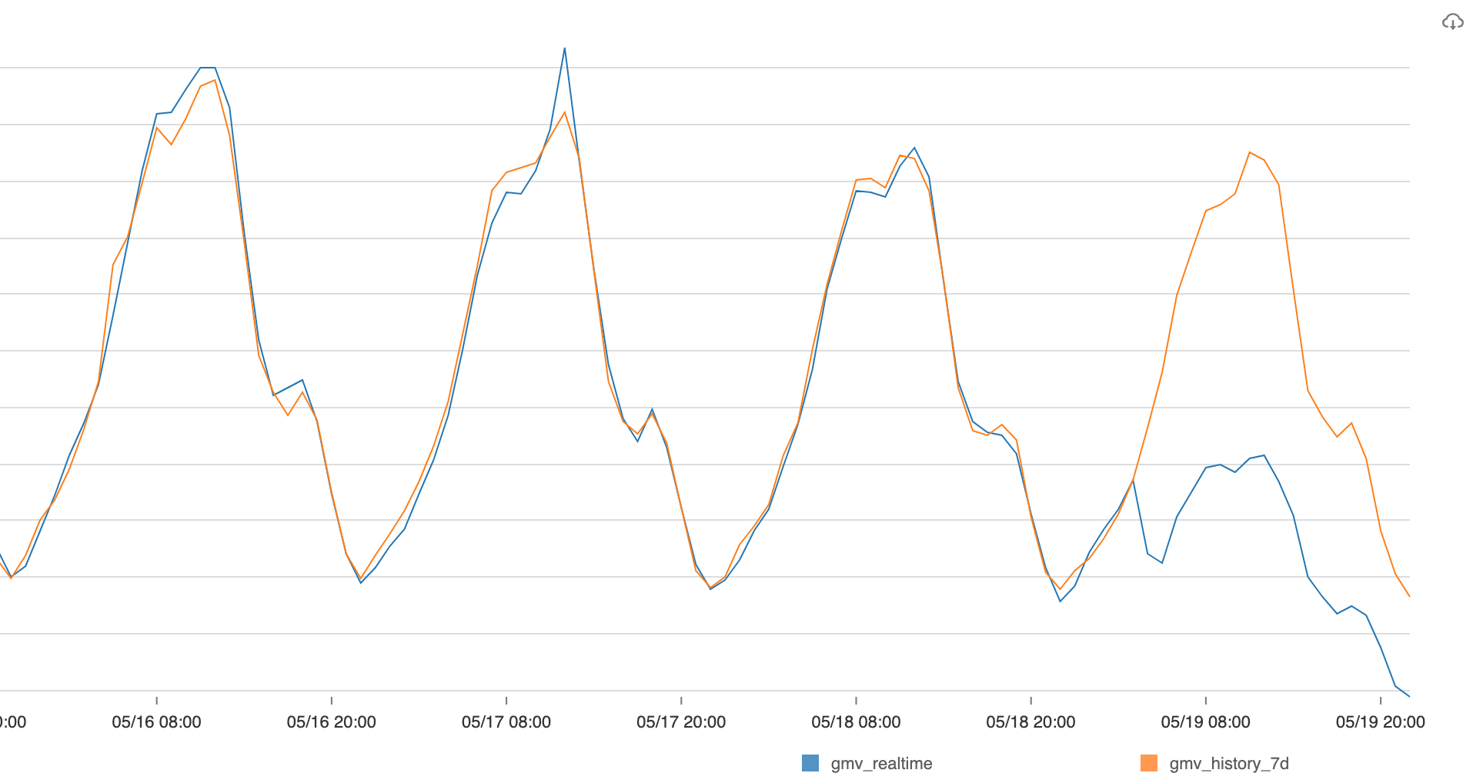

## Producer

There's no obvious drop WoW:

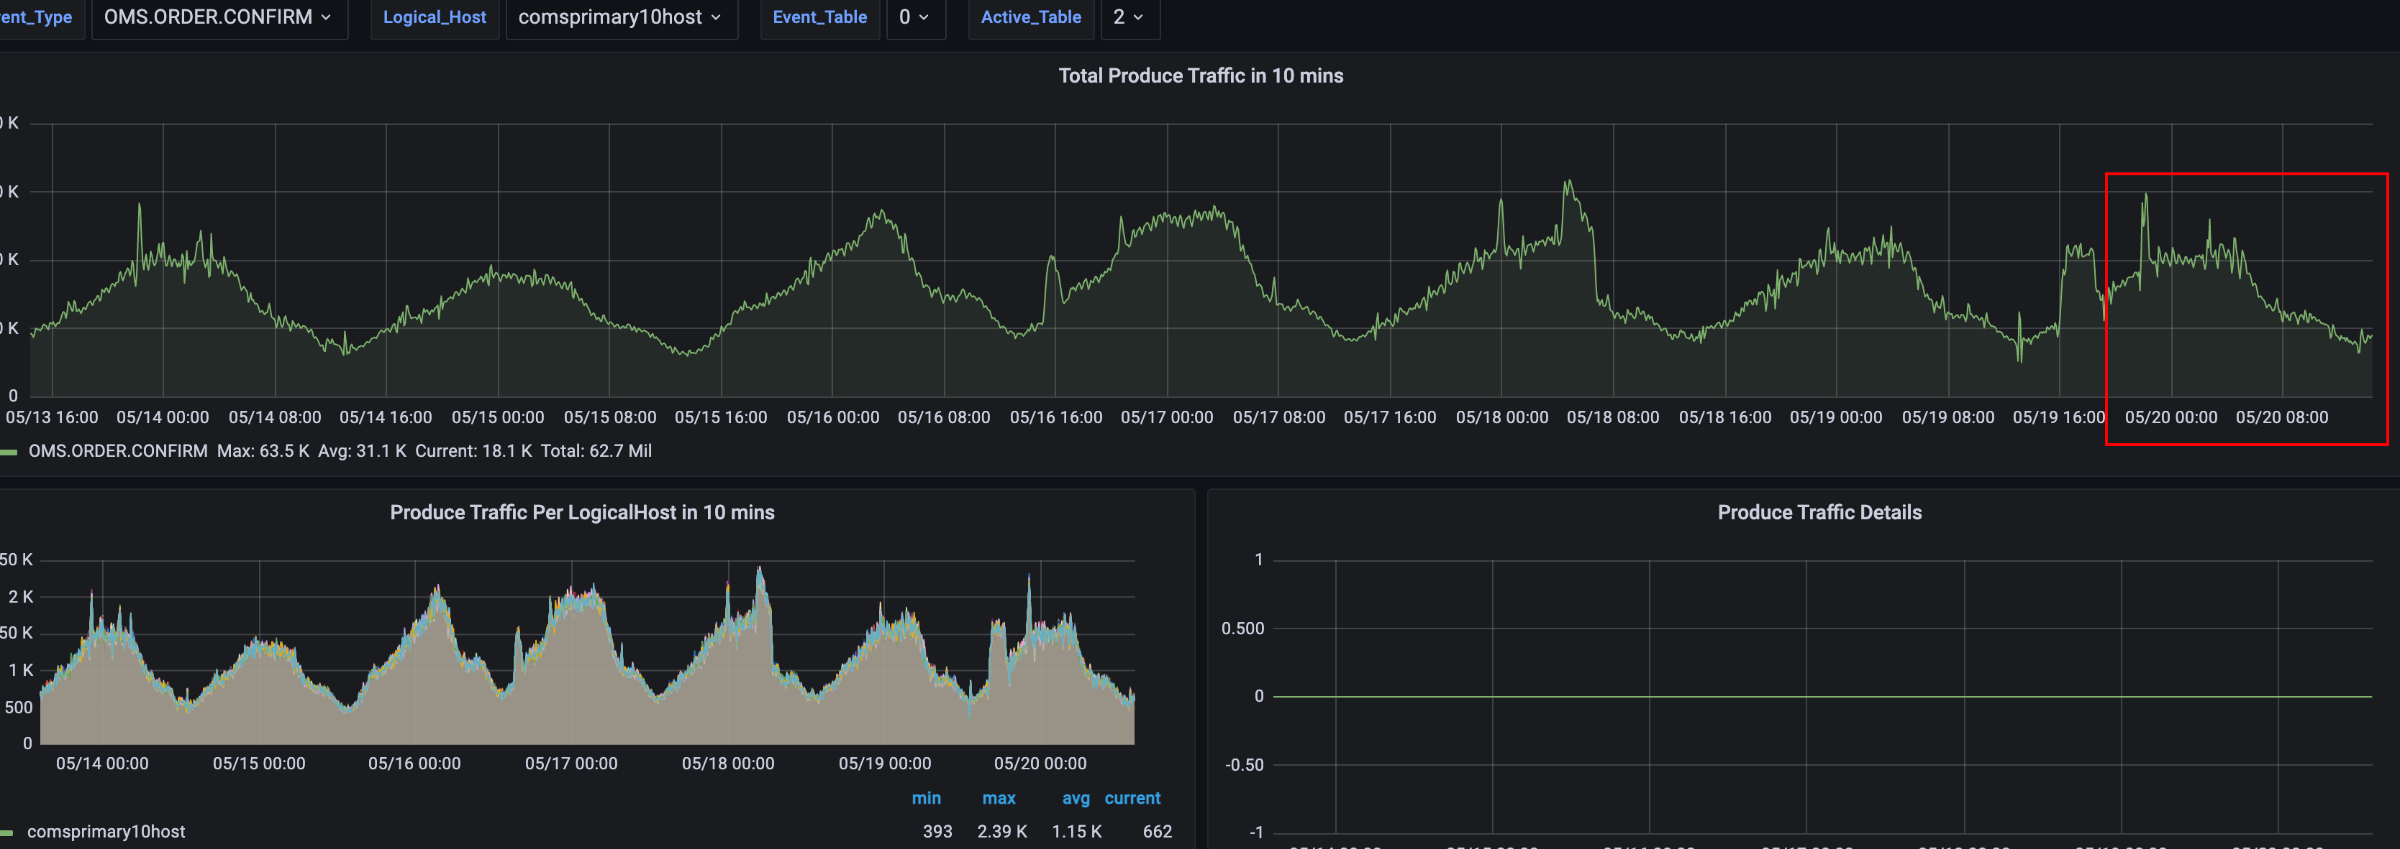

## Consumer

There's a drop:

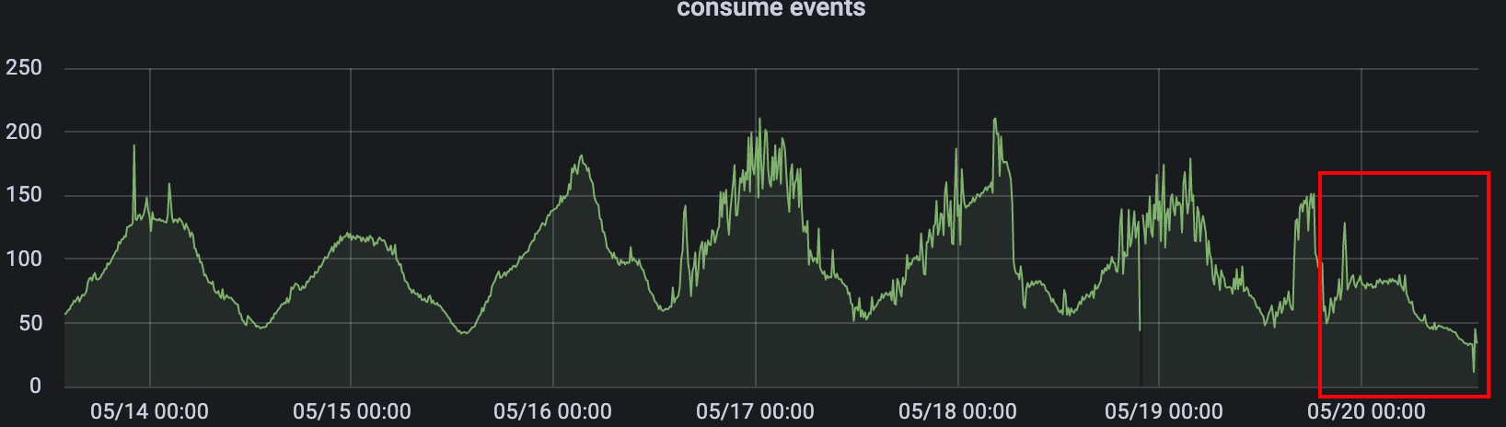

From the metrics monitoring of the cloud console, we can also see the gap:

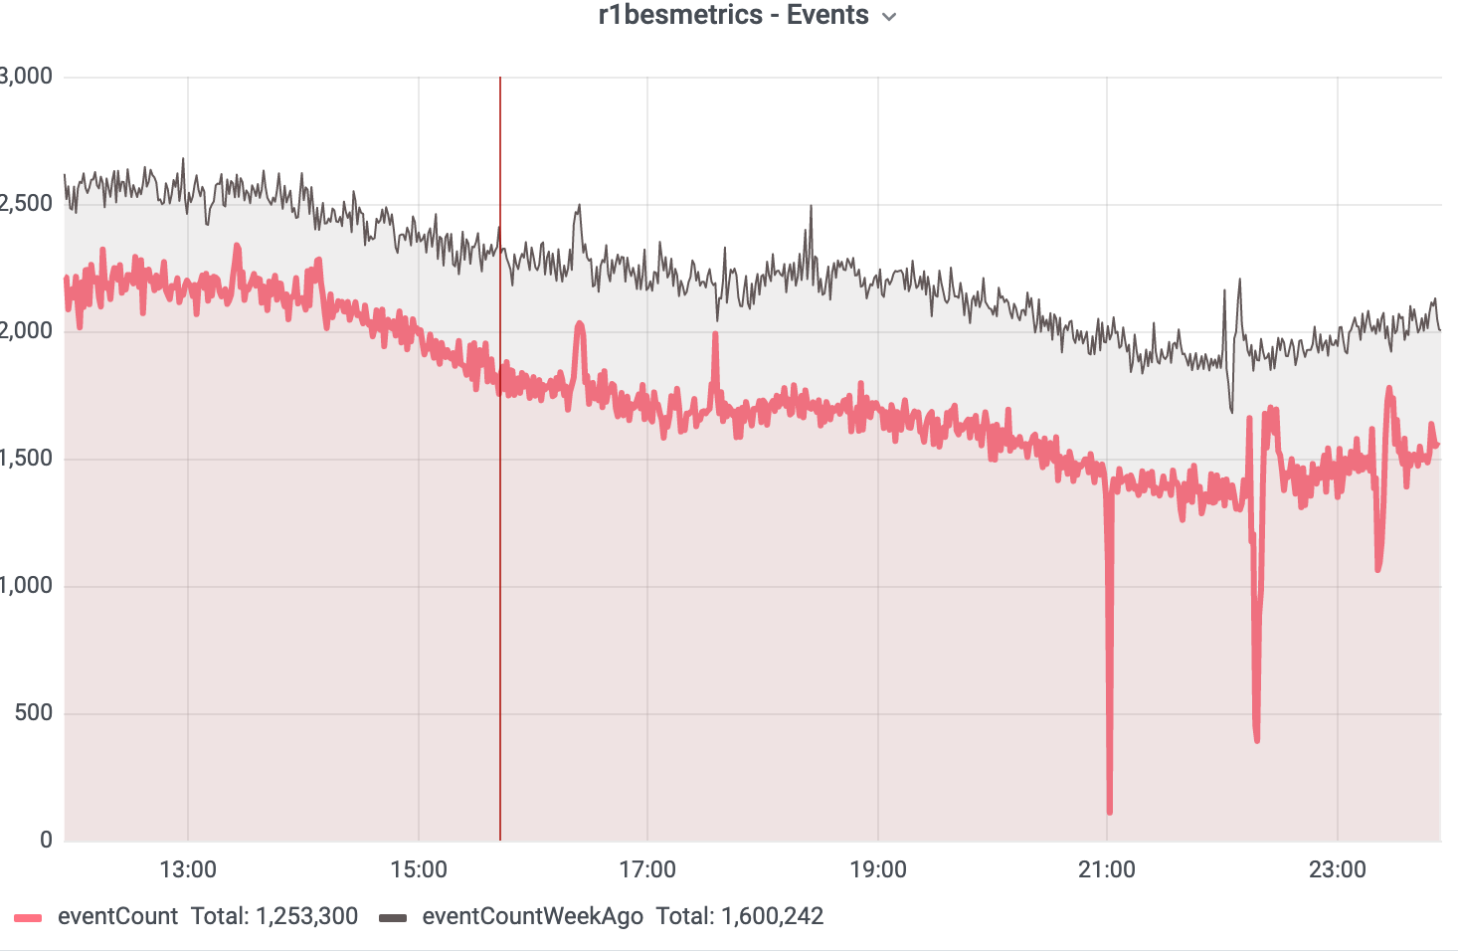

## Kafka Rebalance

There're many rebalance happened around the time the issue started:

